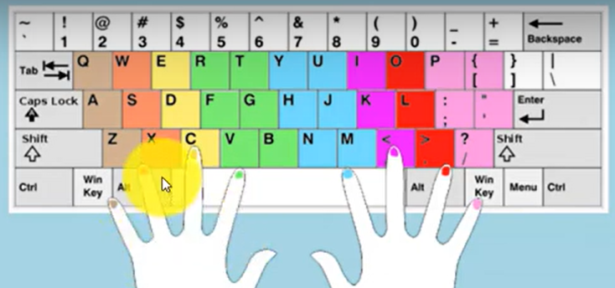

🡺Mechanical Keyboard ==SteelSeries Apex Pro

